2.1 I can prepare content for my webpages so that it is ready for editing and formatting

When creating text for my website I first created a draft using Microsoft Word. I used the tools available in Word to check for any spelling or grammar issues. Using the Web Layout view option in Word helped to give me an overview of how I wanted my text to be laid out on the screen and what kind of styles and colours I might want to use on the website.

Below is an example of how a word document looks in the Web Layout View in Word;

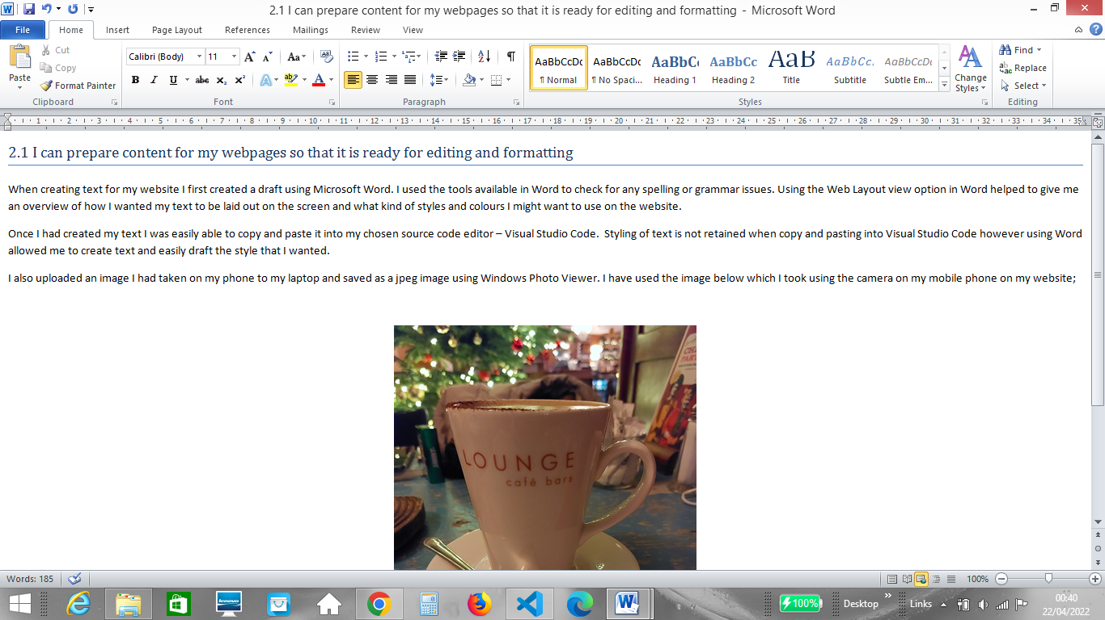

Once I had created my text I was easily able to copy and paste it into my chosen source code editor – Visual Studio Code. Styling of text is not retained when copy and pasting into Visual Studio Code however using Word allowed me to create text and easily draft the style that I wanted.

I also uploaded an image I had taken on my phone to my laptop and saved it as a jpeg image using Windows Photo Viewer. I have used the image below which I took using the camera on my mobile phone on my website;

